**Aim: To design a Remote app**

**Procedure:**

1.choose any frame and make it more effective using text and color

2.create the image don’t paste it directly

3.add more details for menu

4.give the prototype connection

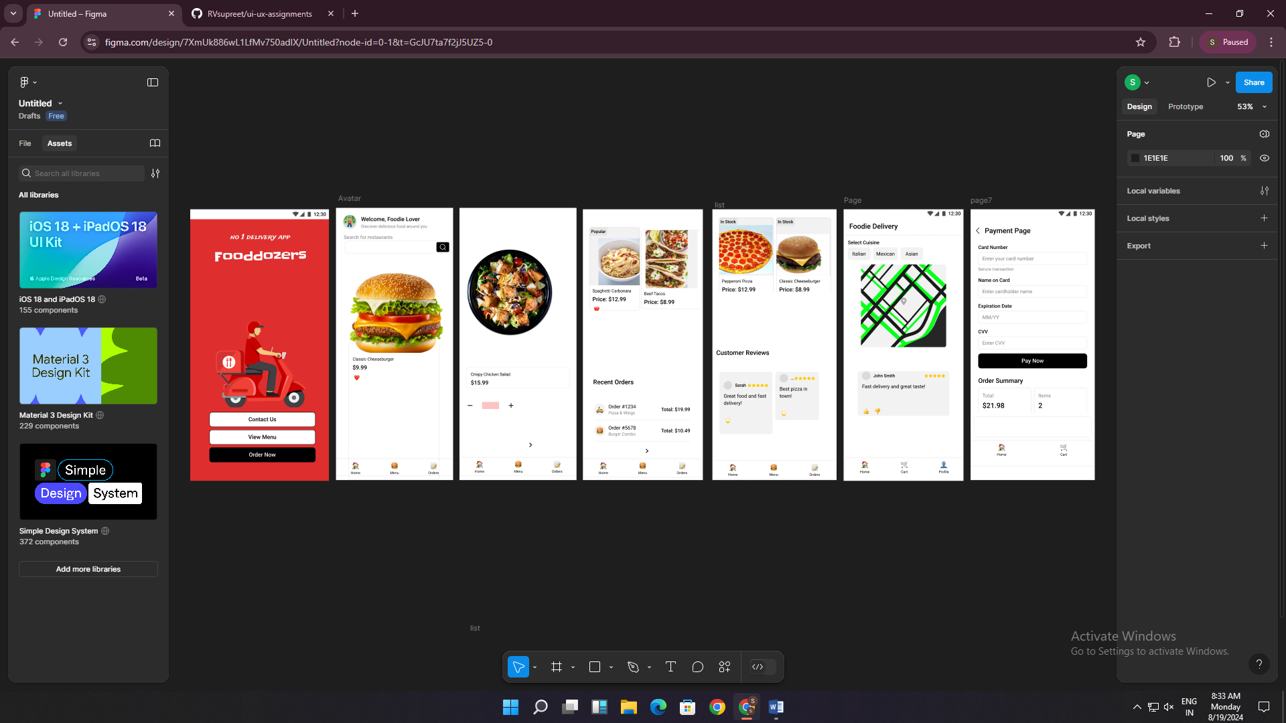

Result:

thus the remote app has been created .